INTRODUCTION
This is a Brazilian ecommerce public dataset of orders. The dataset has information of 115k orders from 2016 to 2017 made at multiple marketplaces all around world. Its features allow viewing an order from multiple dimensions: from order status, price, payment and freight performance to customer location, product attributes and shipping data. We also released a geolocation dataset that relates zip codes to Lat/long coordinates.
After a customer purchases the product from Online Store a seller gets notified to fulfil that order. Once the customer receives the product, or the estimated delivery date is due, the customer gets a satisfaction survey by email where he can give a note for the purchase experience and write down some comments.
PROBLEM STATEMENT
A. Current Year and Previous Year Overview of the Business
- Find YTD, QTD, PQTD Sales, Profit and Quantity
- What are Current Year Sales and Profit trend for different Market all around Globe?
- Comparison of Current Year and Previous year Sales for different Category
B. Market Analysis
1. What is Percentage of sales with respect to different Market Region?
2. Sales by Country for different Regions
3. Do a Pareto Analysis to know the best performing countries
C. Product Analysis
1. What are the bestselling product categories? Compare for Sales, Order Quantity, Profit per order, and Profit margin
2. Do a Basket Analysis to know the pattern of product purchase
D. Customer Segment Analysis
1. Customer Segment Analysis to find Sales, Order Quantity, Customer Count, Profit, Profit margin for each Segment
2. Ranking of Market Region for number of Customer count each Year
3. Find Customer Order Frequency
E. Shipment Analysis
1. Find Total Shipments completed, Ongoing Shipments, Average days to ship a product, number of on time deliveries and % of on time deliveries
2. What is country wise average shipping days?
3. What is Ongoing deliveries status?

DATA DESCRIPTION
This is a commercial data, it has been anonymised, and references to the companies and partners in the review text have been replaced with some other names. The data was cleaned as per the requirement, the blank fields were populated to have a meaningful information in context with the domain. The date fields were cleaned and null dates were populated with dates.
Metadata:
- Total number of rows – ~115K
- Total number of Fields – 39
- Visualization Tool – Tableau Desktop
- DS Connection – Extract
METHODOLOGY
First, the problem was defined, and the data analysis questions were written. The Stakeholders for the project were identified. Next, the sources were found, the data was collected, and unnecessary data was cleaned. The data analysis was performed, and the initial dashboard was built. After verifying that the prototype meets the goals of the project, we need to find the actual data and build the dashboard. Finally, we need to share the dashboard and maintain it so it becomes a useful tool for the audience.
DESIGN METHODOLOGY
Main Story Line
This is a Story Point which collectively have all the dashboard in the form of story. Each time we click on a story point will give the information of that particular dashboard.
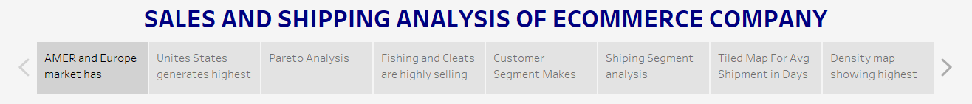
Dashboard 1
The First Dashboard is designed in Tableau Desktop to show the Current Year and Previous Year Overview of the Business. It consists of YTD, QTD and PQTD KPI for Sales, Profit and Quantity Sold. Combo chart with column and line chart and a candle chart.

Dashboard 2
The Second Dashboard is designed in Tableau Desktop to show the Market Analysis. The dashboard has Filled Map chart with different regions, custom rounded bar chart, and a Pareto chart based on 80:20 principle.
Dashboard 3
The Third Dashboard is designed in Tableau Desktop to show Product Analysis. The dashboard contains a combo of bar chart and a lollipop chart to show different measures to analyse product, Basket Analysis chart to show the purchase pattern.
Dashboard 4
The Fourth Dashboard is designed in Tableau Desktop to show Customer Segment Analysis. It contains a KPI Bar chart to show different measures, Pie chart, Bump or Rank chart, and a Frequency chart
Dashboard 4
The Fifth Dashboard is designed in Tableau Desktop to show the Shipment Analysis of the products. It contains a KPI banner to show different parameter for shipping, filled map country chart, and a grid view to show the ongoing status of deliveries.

TABLEAU DASHBOARD
Dashboard 1
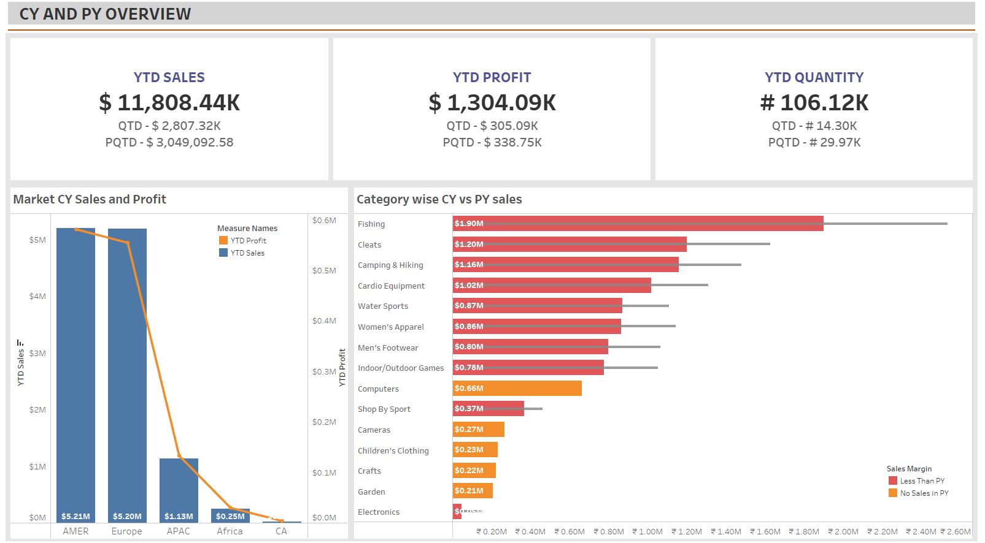
Dashboard 2
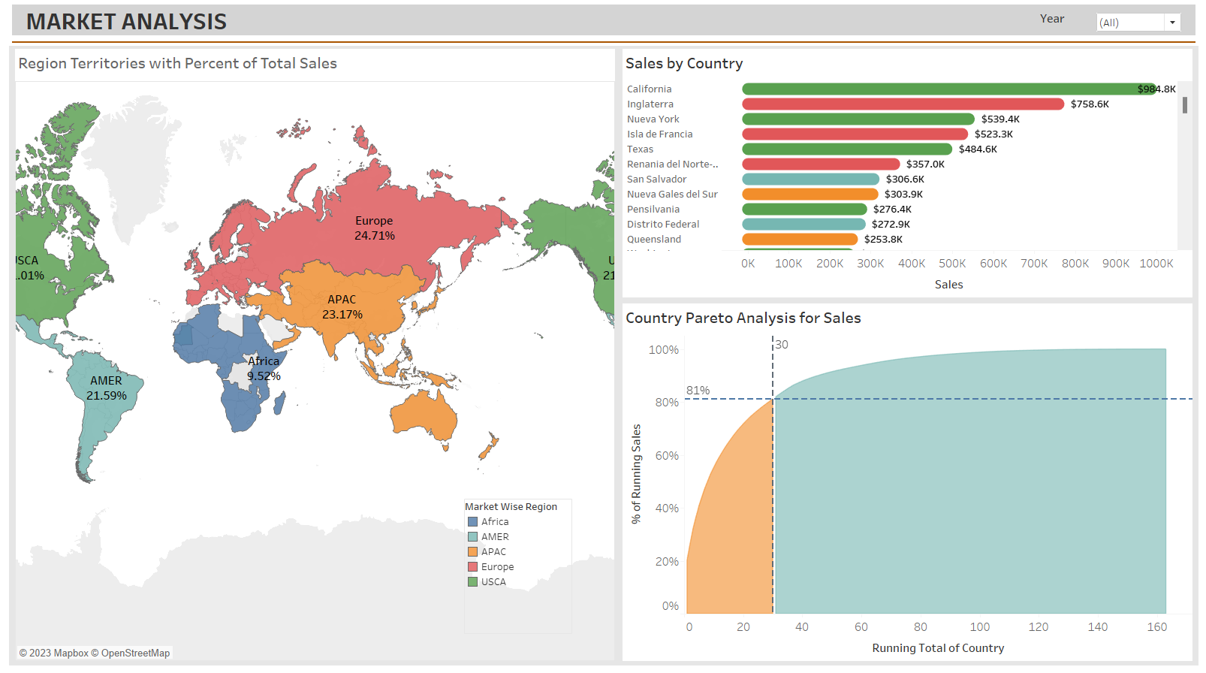

Dashboard 3
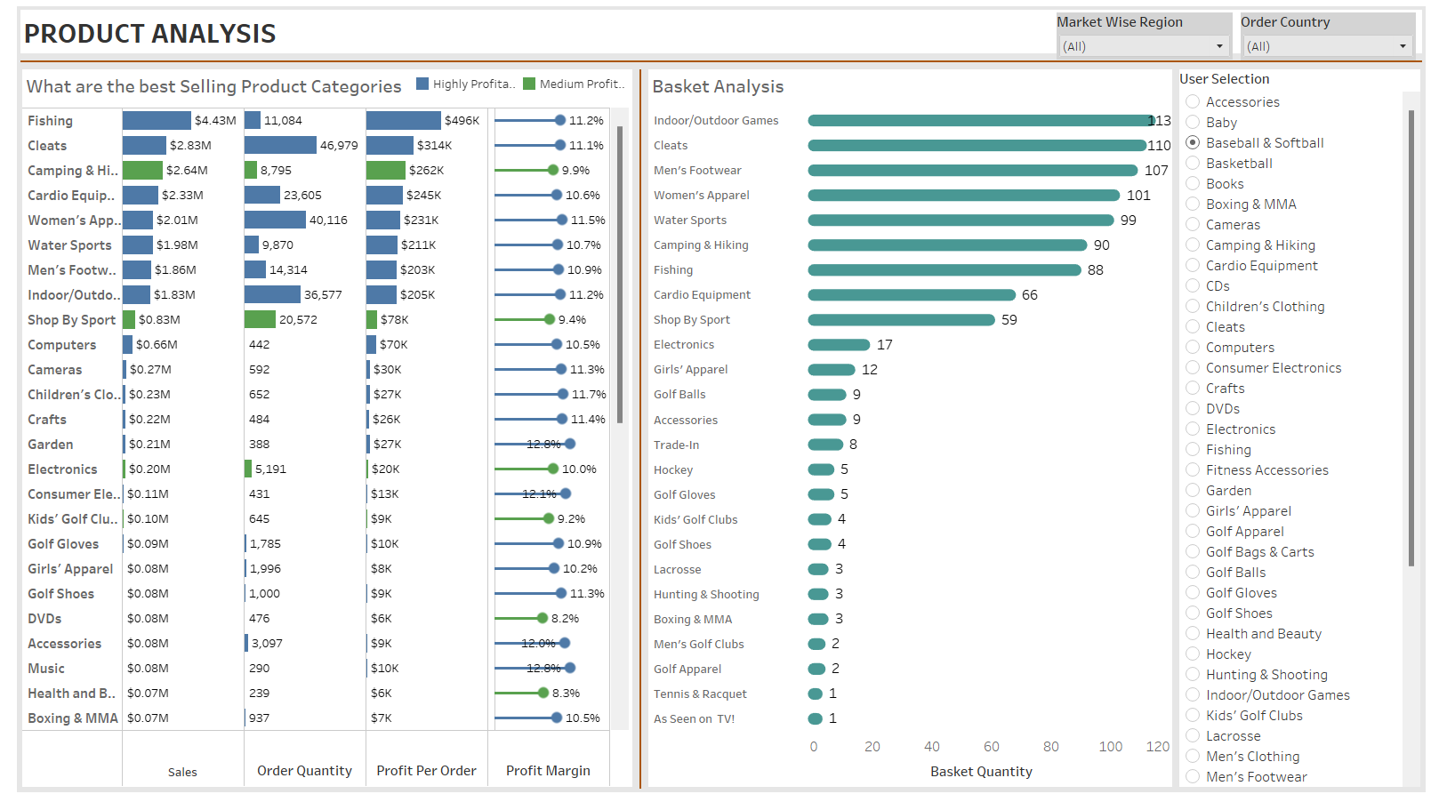

Dashboard 4
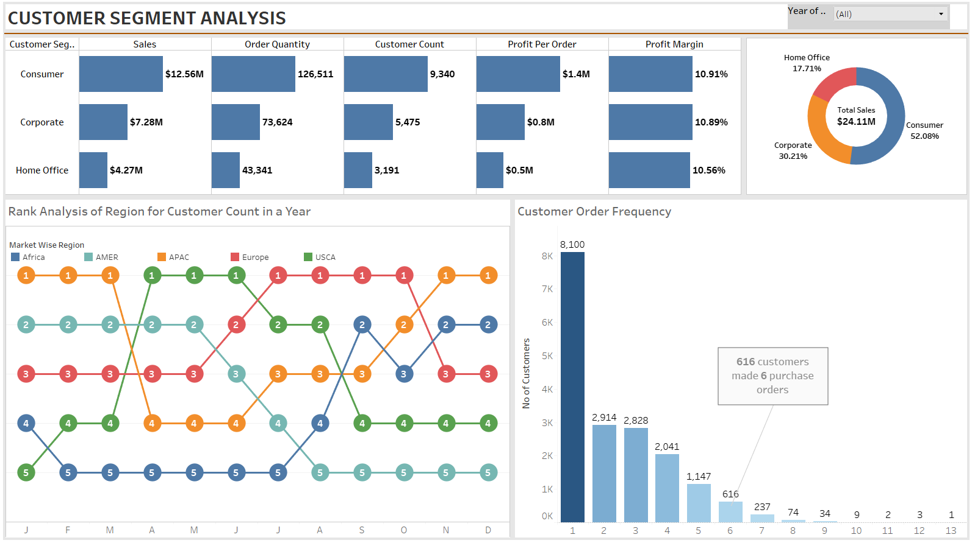

Dashboard 5
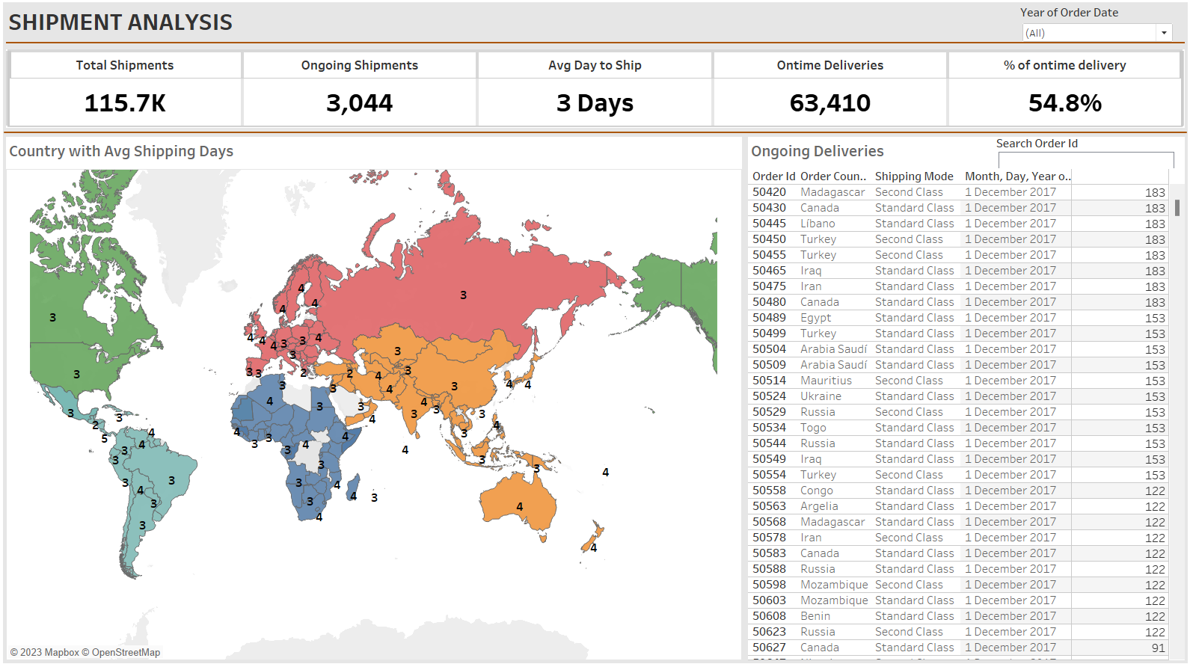

INSIGHTS GAINED
- QTD Sales are decreasing compared to PQTD Sales, which gives an insight that business is going down Quarter-on-Quarter. The same is case for the Profit and the Quantity Sold the Quarter-on-Quarter Profit and Quantity are dropping.
- AMER and EMEA Region contributes to almost 80 % of total Market Share as compared to other regions.
- Fishing Category is the best-selling category all over the market. Computer, Children Clothing, Crafts, Camera’s, Garden are the newly introduced category for the year 2017. Out of newly introduced category Computer category is the best performing.
- Company started selling the products in AMER Region in 2017 and has captured 44.08% of market out of total market in 2017 itself.
- Out of all the countries in the world there are only 30 countries which contributes to around 81% of total sales.
- The Product Analysis help the user to understand the performance of each product and can filter them out with respect to the Region and a specific Country as well. It gives an idea about how the product is performing by Sales, Order Quantity, Profit per order, and Profit Margin.
- Basket Analysis helps user to understand the pattern of purchase done by the customer. It also helps retailers to manage their inventory accordingly to meet the supply and demand.
- Consumer Segment contributes to total 52.08% of total market share, Home office segment contribute to least share of 17.17%.
- In AMER Region maximum number of Quantity were sold in the year of 2017.
- Customer order frequency to purchase more than one order was excellent in the year 2016 where maximum purchase was done as 3 items in one go by 2621 customers. This was dropped to 2325 in 2017.
- Average Shipping Day to deliver the product all over the world is 3 days which shows an excellent shipping management.
CONCLUSION
Company started selling the products in new region AMER in 2017 which was a success and AMER contributed to 44.08% of total Market Share. But the QTD sales were reduced as compared to PQTD sales because the other Market regions were not performing as compared to last year. This needs to be noted and the company can focus on the Marketing Strategies in these regions as well as introducing new Products to sell.
SOURCES
- Ecommerce insights AI- https://ecommerceinsights.ai/#:~:text=eCommerceInsights.ai%20offers%20an%20AI,faster%20and%20ultimately%20sell%20more.
- List of countries by regional classification-
https://meta.wikimedia.org/wiki/List_of_countries_by_regional_classification

